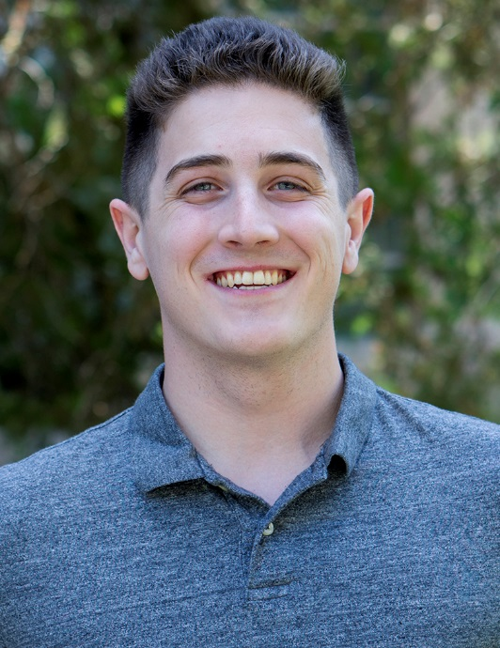

Ian Ratliff
Winter 2018

Hardware Support Employee
of the Quarter
HWS

 | Joseph Mussano  Fall 2017 |  | Erika Shaw  Spring 2017 |  | Jonathan Apostol  Winter 2017
 | Guy Faciana  Fall 2016 |  | Hannah Brinkman  Spring 2016 |  | Hannah Brinkman  Winter 2016
 | Brad Howard  Fall 2015 |  | Hannah Brinkman  Spring 2015 |  | Hannah Brinkman  Winter 2015

Computer Lab Management
IET-Academic Technology Services

